Download Auto it from:

Link: <https://www.autoitscript.com/site/autoit/downloads/>

Open Autoit

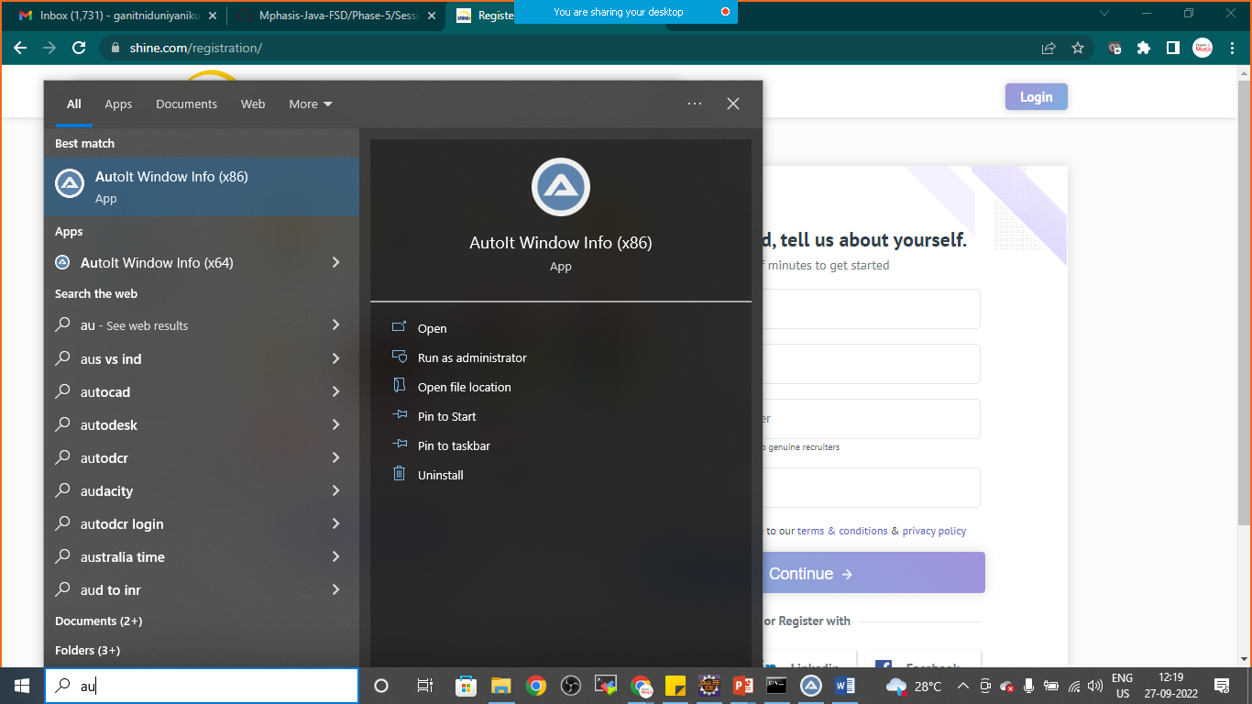

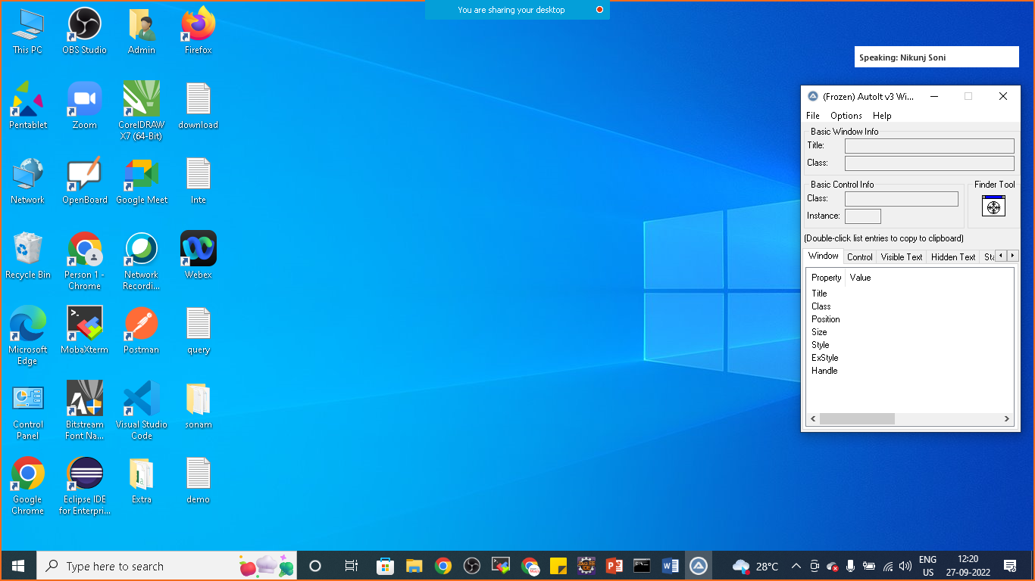

Drag and drop the finder tool on Edit three things

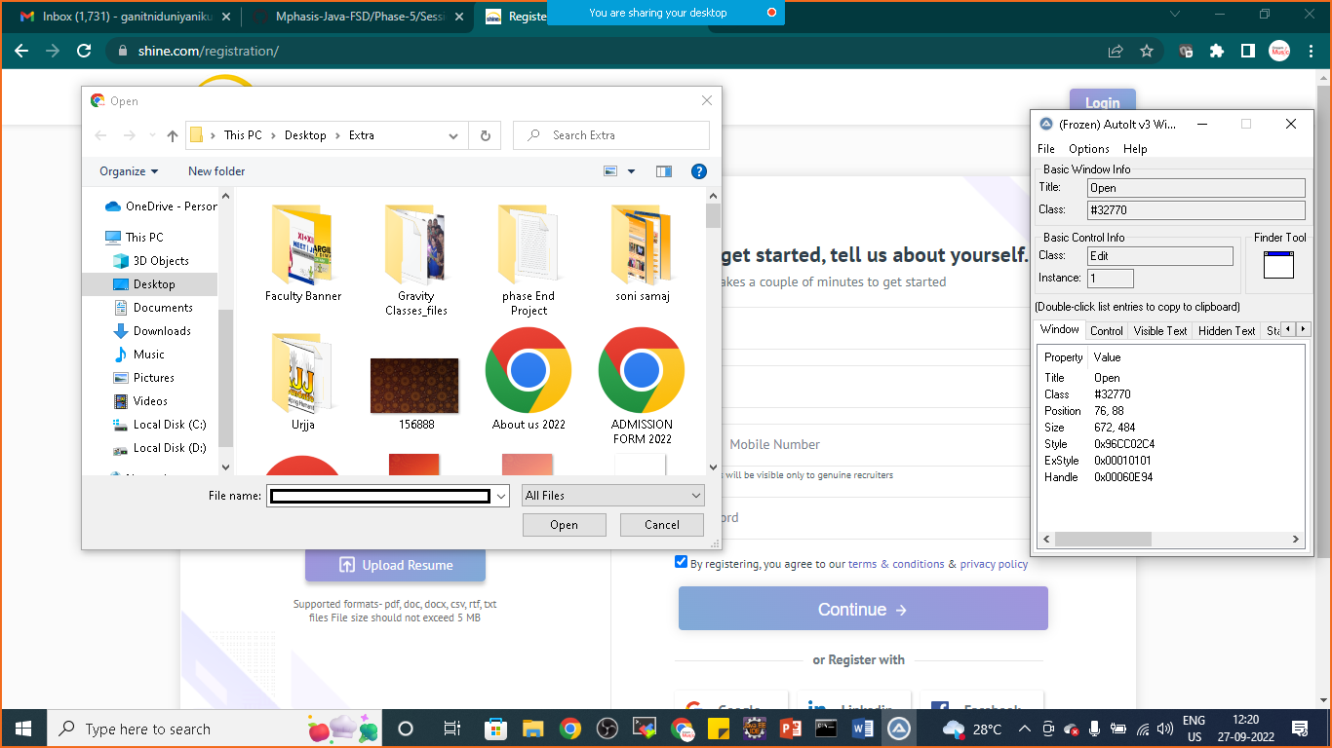

Once you will drag and drop to the file name

Note down three things

**TITLE:** Open

**CLASS:** Edit

**INSTANCE:** 1

Again drag and drop the finder tool to open button

Note down three things

**TITLE:** Open

**CLASS:** Button

**INSTANCE:** 1

Now we will use this things to write automation script

Goto> C:\Program Files (x86)\AutoIt3\SciTE

Click on SciTE

And write the script

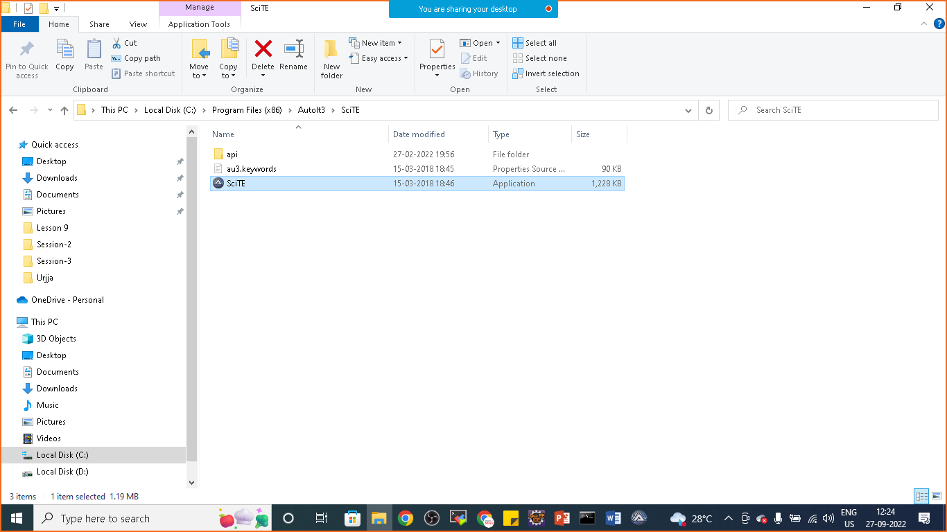

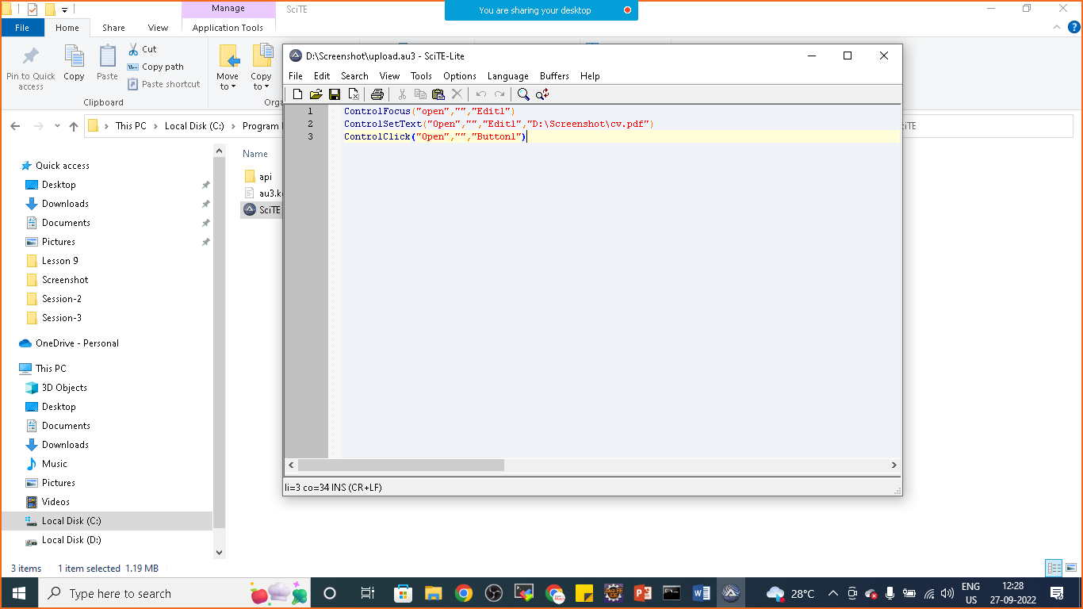

Code:

ControlFocus("open","","Edit1")

ControlSetText("Open","","Edit1","D:\Screenshot\cv.pdf")

ControlClick("Open","","Button1")

Now save the file: upload.au3 extension in the same location where your pdf or document is saved

Now goto the folder where you have saved the script (upload.au3) file

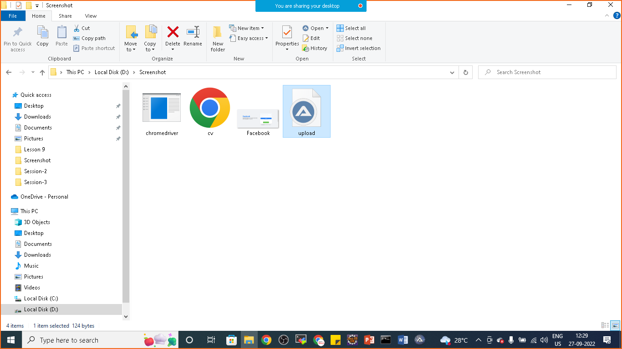

Right click on it and compile the script

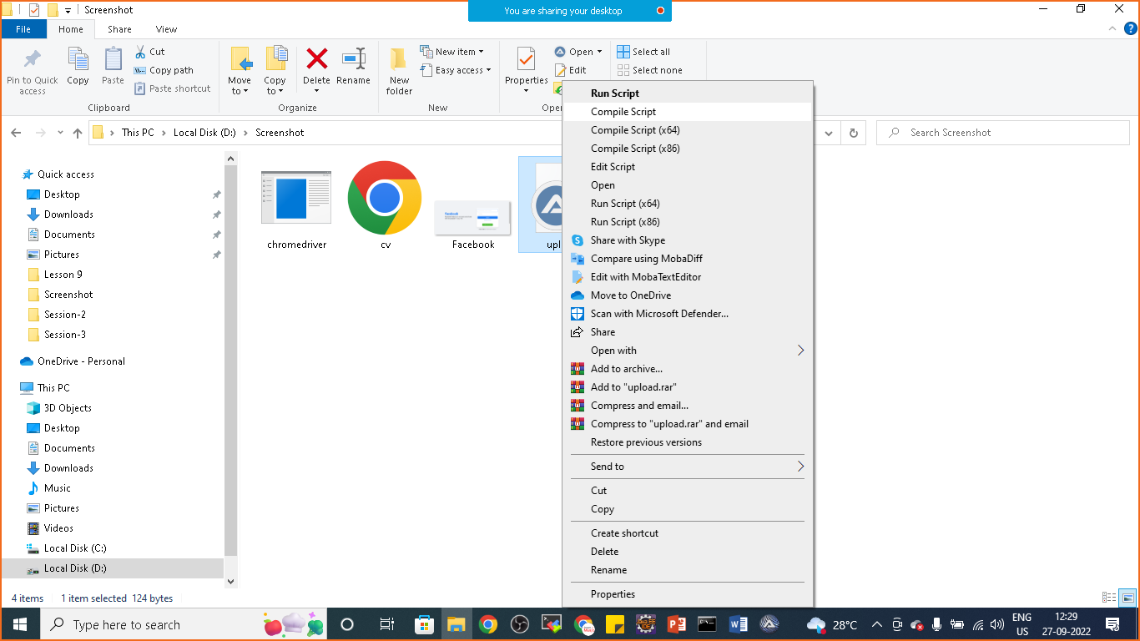

Now it will prepare upload.exe file

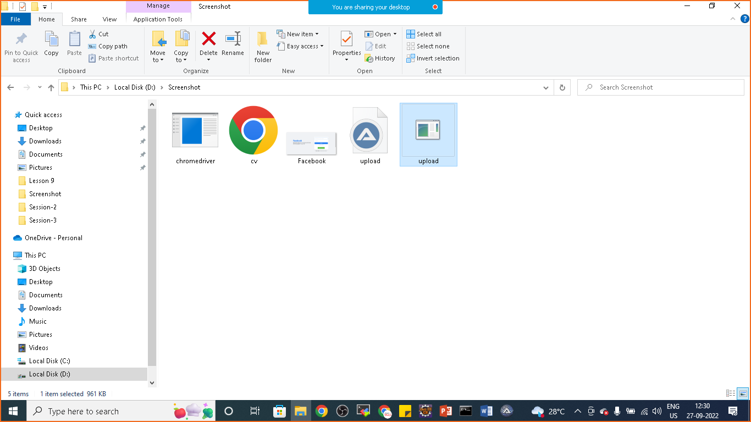

Now we can prepare one java program to upload the files automatically and we can automate windows gui

**package** com.simplilearn.demo;

**import** java.io.IOException;

**import** org.openqa.selenium.By;

**import** org.openqa.selenium.JavascriptExecutor;

**import** org.openqa.selenium.WebDriver;

**import** org.openqa.selenium.WebElement;

**import** org.openqa.selenium.chrome.ChromeDriver;

**public** **class** AutoItExample {

**public** **static** **void** main(String[] args) **throws** IOException,InterruptedException {

System.*setProperty*("webdriver.chrome.driver", "D:\\Phase-5\\chromedriver_win32_Sep_new\\chromedriver.exe");

WebDriver driver= **new** ChromeDriver();

driver.get("https://www.shine.com/registration/");

driver.manage().window().maximize();

WebElement name= driver.findElement(By.*id*("id_name"));

name.sendKeys("Nikunj Soni");

WebElement file= driver.findElement(By.*id*("id_file"));

JavascriptExecutor executor=(JavascriptExecutor)driver;

executor.executeScript("arguments[0].click()", file);

Thread.*sleep*(5000);

Runtime.*getRuntime*().exec("D:\\Screenshot\\upload.exe");

}

}

